Preliminary spool motor sizing and high level controller design

Owen Lu

Electroimpact Inc.

owenl@electroimpact.com

*Abstract*—This document details the calculations that were done to estimate the size of motor that can be used to control the dancer system via motors placed on the spool. These calculations take into account the controller response as well as motor specifications. The calculations were then validated by a Bosch IndraDrive system using a pure feedback control scheme to control tow tension.

# Introduction

This project has been undertaken in order to remedy tow slack issues in the 777 project. Using servo drives, it is hypothesized that high bandwidth control of the dancer position can be achieved with no tension loss. Subsequently, the tension in the tow can also be controlled to a far greater degree of accuracy, improving consistency and reducing the risk of slack.

# Kinetmatic derivation

Since the dancer assembly is kinematically similar to a rope pulley system, one can write by inspection that the dancer displacement against the spring is given by Equation (1).

|  |  |  |
| --- | --- | --- |
|  |  | () |

Where

$v_{o}$ is the feed velocity

$v_{i}$ is the tow surface velocity leaving the spool

$x_{d}$ is the dancer displacement from the initial position

The system can then be written in Laplace domain.

|  |  |  |
| --- | --- | --- |
|  |  | () |

The intent in this system is to use a pure position feedback to control the dancer position and subsequently tension of the system.

Therefore plant $G(s)$ is defined below in Equation (3) as a pure integrator system.

|  |  |  |
| --- | --- | --- |
|  |  | () |

# VELOCITY CONTROLLER DESIGN

In general, inertia ratios are used as a rule of thumb to size motors. This is due to the internal drive controller loops being pre-tuned for ease of use such as in the IndraDrive system. This abstraction allows the user to easily control outputs from a higher level instead of specifying multiple parameters the internal cascade control loops. If necessary, these lower level parameters can be done via Bosch Indraworks software.

Thus, in order to combine this level of abstraction with experimental results and quantify performance a few tests will be performed.

Dependent on the inertia of the load, the ability for the pre-tuned motor to respond to velocity commands will change. We want to treat a few of these systems in different spool configurations as black boxes and measure the FRF to obtain a quick idea of how far performance can be pushed. However, these readings cannot be taken at face value as small signal characteristics do not necessarily translate directly to response of larger signals. Other problems such as saturation and torque limitations will change the response of the system.

Using Bosch Indraworks a FRF can be obtained via the “Frequency Response Analysis” tool. A figure of the output is shown below.

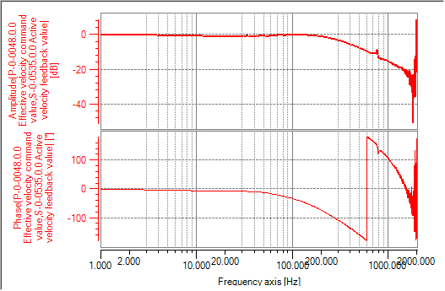

Figure – Bosch Indraworks typical frequency response output

Indraworks software has not unwrapped the angle. The MATLAB unwrap function allows this to be done easily. Figure 2 shows the unwrapped measured response of the velocity loop when the spool and carbon is connected.

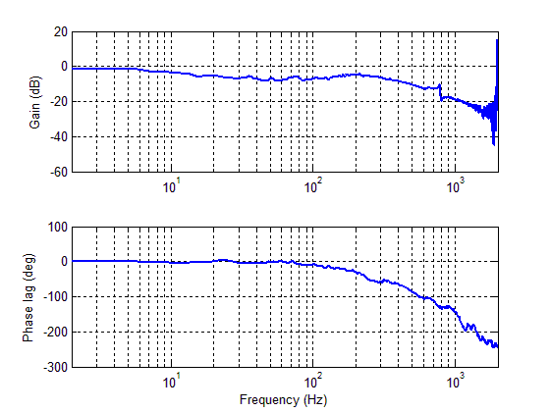

Figure - Unwrapped frequency response

The -3dB bandwidth is near 10Hz using a 4 inch diameter spool of ¼ inch carbon fiber.

The main transfer functions are from the payout surface speed and the displacement dancer reference. Interestingly the payout surface speed is the more important input in terms of dynamic characteristics since $x_{r}$ is unchanging as a set point (constant tension control). Thus, Equation (4) is of primary interest.

|  |  |  |
| --- | --- | --- |
|  |  | () |
|  |  | () |

It is clear from (4) that step velocity inputs are rejected by final value theorem. Simulation can be done to determine dancer travel based on the momentary ramp input of 0.5G acceleration, and sizing can be conducted.

Since the characteristic equation is second order, it is easy to develop rules of thumb based on measurements $r_{s}$ to optimize the performance of the system and maintain consistency.

The bandwidth can be calculated below with the simple approximation.

|  |  |  |
| --- | --- | --- |
|  |  | () |

Then the damping ratio can also be calculated.

|  |  |  |
| --- | --- | --- |
|  |  | () |

Therefore specifying $ω_{b}$ and $ζ$ while simultaneously measuring $r_{s}$ we can obtain both controller parameters to maintain the same system response in theory. This should be done in context of the system limits, such as drive saturation, and torque limitations which will be discussed in future documents.

# Optimal PI controller design

Since packaging is the primary concern in this design, the natural question is what the minimum specification of the motor that can satisfy the design requirements. This is a bit of a simplification, as power density differs from different servo designs, however is sufficient for a first look.

The reason PI controllers are of interest is that they are easy to implement and satisfy the basic requirements of the system. Interestingly, selection of optimal controllers is tied directly to the motor sizing. Thus, the problem can be thought of in two directions.

The problem can be stated below. Given a dancer travel limit $l$ and two cases: step velocity input disturbance at 2000in/s, and 0.5G ramp input disturbance to 4000in/s find the lowest torque requirement. Simulation will be used prove the viability.

Assume that the following process takes place.

1. The system is turned on with some nominal tension in the tow
2. The reference is set and the servo controls the dancer to the reference position via velocity input to the motor
3. After this, one of two scenarios will be realized
   1. Case 1: A step velocity input at the feed is activated at 2000in/min
   2. Case 2: A ramp velocity input at the feed is activated at 0.5G

Although control problems generally wish to shape the response to the reference position to some desired specification, in this application it is far less important than the response to the input disturbance. This is because the process of tensioning before payout can be thought of as initialization since the tension should be constant. However the process of payout causes the dynamic response of $x_{d}$ which we wish to be constant.

Design of the controller is done for Case 1 which causes the larger disturbance in $x_{d}$ which is explained later.

Assuming that the tension has reached its initial reference, the payout process begins with a step input of 2000in/min at $v_{o}$. The fastest that the surface speed $v_{i}$ can reach $v_{o}$ is limited by the maximum torque of the motor .

|  |  |  |
| --- | --- | --- |
|  |  | () |

This means that in the best case, to reach an equilibrium offset, by achieving two equal speeds, the motor is simply turned on, run at maximum torque until no speed difference exists.

The problem can then be reinterpreted, to solve for the controller.

The response of the $v_{i}$ the tow surface speed can be written as .

|  |  |  |
| --- | --- | --- |
|  |  | () |

Using the characteristics of a first order system we can solve for the form of

Let

|  |  |  |
| --- | --- | --- |
|  |  | () |

Solving for $C(s)$ gives a proportional controller.

|  |  |  |
| --- | --- | --- |
|  |  | () |

The initial acceleration of $v_{i}$ is specified by $τ$ since $H\left(s\right)$ is first order. Simply setting the acceleration to the acceleration corresponding to maximum torque allows us to limit the dynamic torque on the motor below this value.

|  |  |  |
| --- | --- | --- |
|  |  | () |
|  |  | () |
|  |  | () |
|  |  | () |

Therefore, proportional gain that maximizes the performance of the dancer response to disturbance input can be written as a function of $T_{m}$ the maximum torque.

|  |  |  |
| --- | --- | --- |
|  |  | () |

Selection of such $K_{p}$ ensures that torque limits are obeyed. Now the problem becomes the effect of integral action. Recall Equation (7). It is clear that the damping ratio is directly affected by integral time. Written in terms of the integral transition bandwidth $ω_{I}$ is below.

|  |  |  |
| --- | --- | --- |
|  |  | () |

Therefore, the damping ratio of the response is directly affected by the choice of $ω_{I}$, and $r_{s}$. The effect of $r_{s}$ is accounted for later. So the larger $ω_{I}$ the faster zero error is achieved, however with the more oscillation as a trade off.

Suppose that we set the damping ratio to $\frac{1}{\sqrt{2}}$ which is slightly underdamped.

|  |  |  |
| --- | --- | --- |
|  |  | () |

At this point all controller parameters are specified by the maximum torque of the motor, the spool radius, and the effective inertia at the spool shaft. Thus, changing the maximum torque, we can see the effect on the performance of the system.

# Simulation

The simulation was conducted in SciLab an open source software with the following block structure.

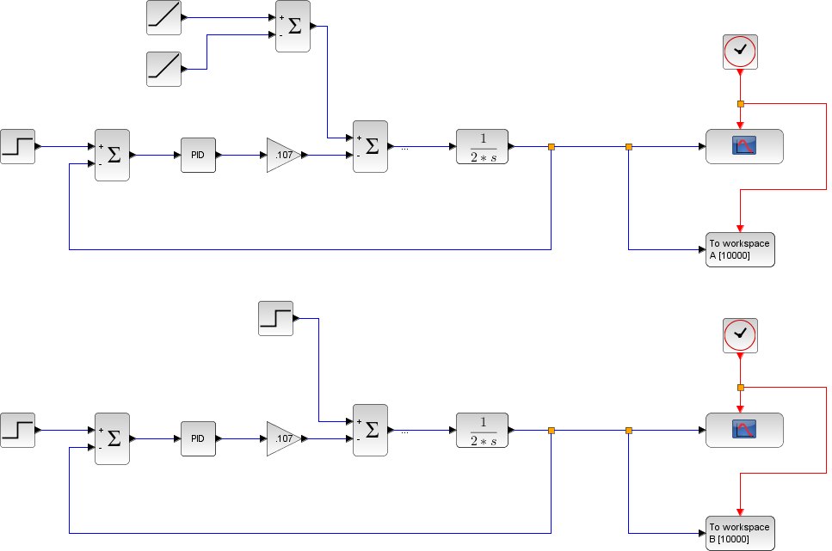

Figure – Initialization and step velocity input simulation

Below is an example simulation comparing the specified PI controller to the optimal bang-bang control to get to cruise velocity as fast as possible.

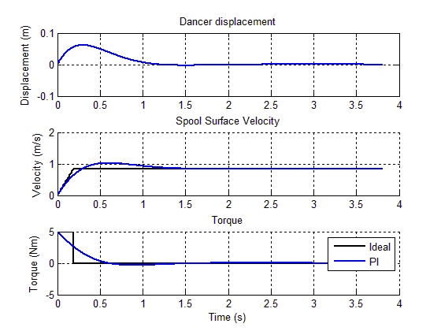

Figure - Optimized PI control vs bang-bang control

Simulation parameters are shown in the Table 1.

|  |  |
| --- | --- |
| Parameter | Magnitude |
| Maximum torque (Nm) | $$5$$ |
| Effective inertia (kgm2) | 0.05 |
| Spool diameter (in) | 3.5 |
| Payout velocity (in/min) | 2000 |

Table - Simulation parameters

Below is the simulation of the curve describing trade-off between maximum torque and maximum displacement from equilibrium. In practice, approximately 2in or less is acceptable, for safety we may choose something around 8-12Nm after the reducer to be the output. This number corresponds to the reducer output at peak torque since such a torque is maintained for a very short amount of time.

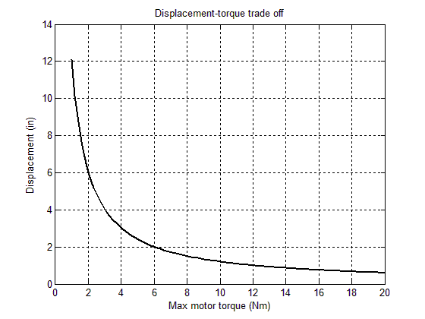

Figure - Displacement amplitude vs. maximum torque

Note that the response of the dancer displacement to the reference displacement is dominated by the same poles as the response to the payout, these do not need to be tuned. However, since a zero exists, we choose a pre-filter to cancel the zero and maintain unity gain.

|  |  |  |
| --- | --- | --- |
|  |  | () |

A sample response choosing 5cm as the reference point is shown below. Notably controller constants are functions of the spool diameter. Thus, performance will vary as time goes on unless the controller parameters are continuously modified with sensor input.

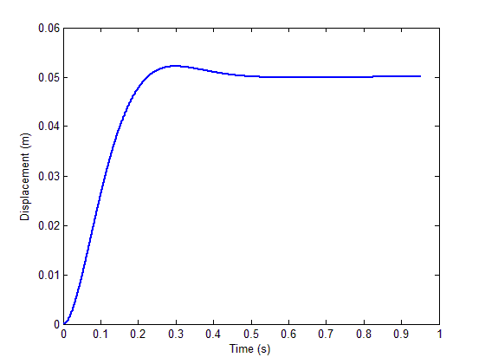

Figure - Step response to dancer displacement input

This analysis concludes that a simple continuous PI controller paired with a properly geared motor can necessarily generate the control signals required to bound dancer displacement and subsequently tension without worry of saturation and exceeding torque limits specified.

# Experiment and theory

## Step input reference

Notably, the theoretical model which is outline in Figure 3 does not fully describe the process that generates velocity commands. In reality, multiple sub loops exist as well as other trajectory generation related algorithms. Thus, there will be limitations in the model’s ability to predict the outcome.

Initially a proportional controller was used by request from upper level management. The dancer position was set at 1in and an approximate step velocity payed out. The graph comparing the theoretical and experimental results is shown in Figure 7.

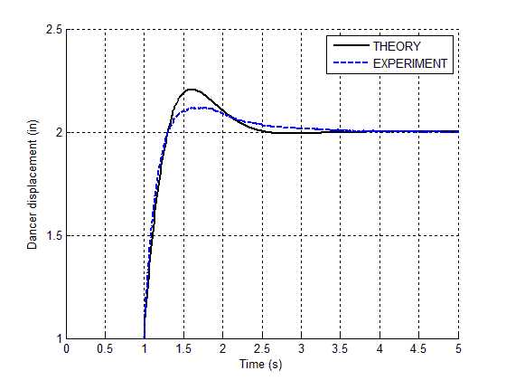

Figure - Step input comparison between model and experiment

The proportional action near the beginning of the step traces the experimental performance almost perfectly, however the integral action is noticeably more damped than expected. This is favorable to the theoretical response, however the reason for this has yet to be identified.

# Conclusion

Preliminary testing of the system using Bosch IndraDrive software shows that the motor combined with the tuning method is likely capable of providing sufficient torque for operation. However, with the current internal loop tuning, torque may spike over the rated torque for a small amount of time ~0.1s causing a software fault. More study is necessary to ensure that the software settings are correct and allow safe operation. Possible upgrades to the mechanical system may also be necessary to ensure that the tow is able to payout at proper speeds.